Concern Universal
Brazil Impact Assessment

Implemented by Casa Pequeno Davi and Concern Universal Brazil

Brazil, March, 2014

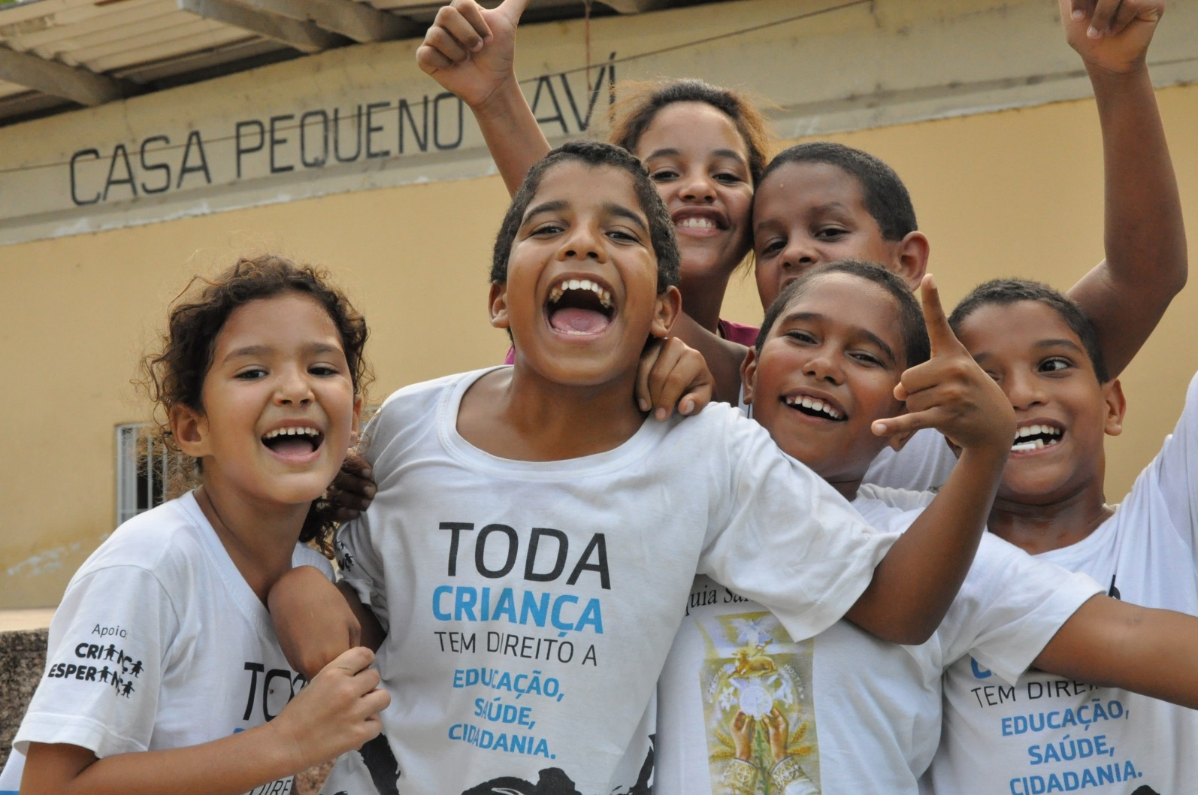

Researchers and authors

Mirley Jonnes Pequeno da Silva | Casa Pequeno Davi
Joelma Oliveira | Casa Pequeno Davi
Thiala Gomes | Casa Pequeno Davi
Dimas Gomes da Silva | Casa Pequeno Davi
Maria dos Anjos de Freitas | Social Services Student - Federal University of Paraíba
Gildete de Paiva | Social Services Student - Federal University of Paraíba
Dr. Lúcia Lemos Dias | Doctor in Social Services / Human Rights Sector - Federal University of Paraíba
Aline Oliveira | Concern Universal Brazil
Angela Brightling | Country Director, Concern Universal Brazil, Team Leader
James Treasure-Evans | Concern Universal UK Office, Impact Assessment Advisor
José Bernardo Cañas Hernández | Concern Universal UK Office
Janet Smith | Volunteer

Index

- Executive summary…………………………………………………………………. 4
- Introduction / purpose of the impact analysis……………………………………. 5
- Methodology…………………………………………………………………………. 7
  - Tools……………………………………………………………………………... 8
  - Analysis of data…………………………………………………………………. 9
- Presentation of the resulting outcomes……………………………………………11
  - Personal development…………………………………………………………. 11
  - Education………………………………………………………………………... 15
  - Employment……………………………………………………………………... 22
  - Promoting a culture of peace………………………………………………….. 26
- Conclusions and recommendations……………………………………………….. 32

- Executive summary

During February and March 2013, Concern Universal, together with our local partner Casa Pequeno Davi (CPD), completed an evaluation in to the long-term impact of the lives of young people who took part in the activities of CPD from 2002-2012. The research focused on four areas, each of them highly relevant to the wellbeing and quality of life for young people in Brazil: Personal development; Education; Employment; and promoting a Culture of peace. The assessment found significant evidence of the positive impact of CPD’s work in these areas, as well as other areas such as family relations and citizenship.

The research found that the key impacts on young people, of CPDs work, include higher self-esteem and confidence, with 88% affirming they have more “control over their own lives”; a higher level of education than others from the area who did not attend CPD activities, with a majority of participants (74%) completing at least basic education; good employment opportunities with 70% of CPD participants accessing work, the majority attributing this to the support they received from CPD; an improvement in the level of respect people had for others, with 91% understanding that dialogue is essential for conflict resolution; and lastly an improved awareness of basic human rights, with 87% acknowledging that what they have learned has contributed to improvements in key parts of their life, including education, health, work or family life.

The achievements made are even more impressive considering the high level of abuse of children’s rights in the locality, including poor access to basic services, child labour, domestic violence, sexual abuse and exploitation.

The evaluation also highlighted a number of key challenges which continue to exist. Despite a wider understanding of rights, and participation in a wide range of activities including taking part in demonstrations for better rights, few of the participants of the programmes have been able to engage in activities to improve conditions in their community after they stopped attending CPD activities. The research also found that more than 30% of former participants have never worked and despite the fact that women have obtained higher education qualifications, few are in employment and the majority of those who are working are earning a lower salary than the male ex-participants.

Despite the economic development of Brazil over the last 10 years and government policies for eradicating extreme poverty, the local context where CPD works is still extremely difficult for children, youth and their families, reinforcing the need to maintain and continually improve the efforts already in place. The information that has been gathered through this evaluation will contribute directly to the process of revising and creating new strategies to resolve or mitigate the challenges that socially vulnerable children and young people face.

This analysis has been an excellent learning opportunity for CPD and Concern Universal staff and for the volunteers involved. According to the young people involved in the process, it provided an important opportunity to collectively reflect on their personal journeys and to contribute to CPD’s strategy discussions so that it continues to be an effective influence in the lives of other children that need support.

Introduction / purpose of the impact analysis

Founded in 1985, Casa Pequeno Davi (CPD) is a non-profit organization (registered charity) based in João Pessoa (a city in the Northeast of Brazil with a population of 770,000). CPD works with socially vulnerable children and young people. Due to high levels of poverty in the areas where CPD works children are exposed to a multiplicity of risks. CPD works to reduce the vulnerability of children in João Pessoa through an integrated programme which uses various educational, artistic, cultural, sport-based, personal development, citizenship and vocational tools to promote opportunities for a better future.

CPD works in the north of the city, close to the centre, in areas that suffer from a number of social and economic problems, such as food and nutritional insecurity, poor quality public services, high levels of youth unemployment and violence, and high usage of drugs (both as users and for trafficking) amongst young people. All of these issues affect children and young people, as well as their families, living in the area. CPD works with young people from Roger, Padre Zé, Porto do Capim, Varadouro, Ilha do Bispo and Centro, with Roger being the focus of their efforts and where their main center is based.

Using a participatory methodology, CPDs mission is “to contribute to the effective implementation of Human Rights, especially those of children and young people in situations of social vulnerability, through integral education actions, community and institutional articulation, and intervention in the public sphere of Paraíba, from the perspective of sustainable development”.

Concern Universal has had a presence in Brazil since 1997, working in partnership with local organisations to fight poverty, inequality, promote justice, dignity, autonomy of people and human rights.

Concern Universal has worked in partnership with CPD since 1998 to improve human rights in Paraíba State. Concern Universal has contributed to the organisational development of CPD, supporting them with planning, monitoring, evaluating and systems development, as well as the introduction of new methodologies and with fundraising to support CPD’s sustainability. In analysing the impact of CPD’s work, this evaluation also analyses the support Concern Universal in Brazil has given to CPD and, through them, to people living in the urban areas of Paraíba state.

This Impact Assessment was an opportunity for the organisation to investigate, collate and document evidence on the long term impact of CPDs work. The study focused on gathering qualitative feedback from former participants of CPD programmes from 2002-2012. This impact assessment is very timely because, despite recent positive changes in Brazil, poverty and the violation of human rights of children and young people still remain high, especially in poor urban areas like Roger.

This impact evaluation seeks to:
- Determine the contribution of change in the lives of those who participated in CPD’s activities, highlighting the most significant changes, their relevance and sustainability;
- Gauge the success and limitations of activities, enhancing the evidence base of the programme, feeding in to the planning of future strategies and approaches;
- Increase accountability towards participants and other stakeholders (contributors, donors, government, etc.);
- Contribute to the sustainability of CPD and broadening of its supporter base by sharing positive lessons learnt through the impact evaluation.

- Methodology
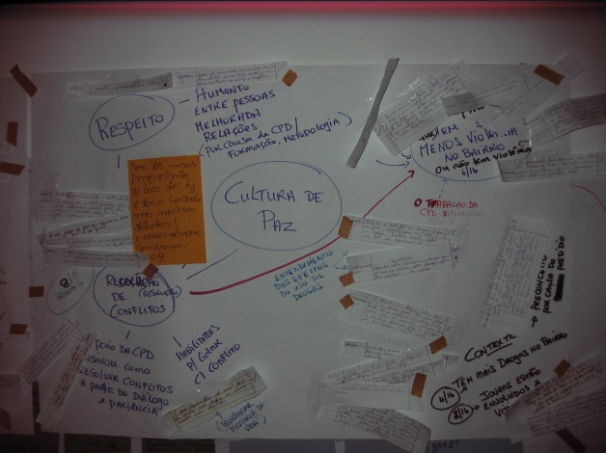
Starting from a methodology built and tested by Concern Universal in similar experiences around the world, the present analysis focuses on the voice of ex-participants of the CPD programme. The evaluation assessed the ‘significant changes’, both positive and negative in the lives (personal, family and community) of the young people during the studied period, and analysed which changes CPD has made a significant contribution to. The analysis has been carried out using a participatory user-led methodology, which priorities the ability of participants themselves to critically analyse the impacts of CPDs work on their lives and to recognise any other significant influences in their lives.

Given that the goal of CPD is to contribute to improving the quality of life and opportunities of children and young people, this evaluation was designed to answer one key question: “what difference has CPD made to the quality of life of people who took part in its activities when they were children?”

In order to answer this question, the study focused on four specific areas of analysis that affect quality of life, namely: a) personal development; b) education (formal and for citizenship); c) access to employment, both formal and informal; and d) ‘living’ a culture of peace.

The research cohort chosen for this study were young people aged between 18-30 years old, mainly from the neighbourhood of Roger (ho-ger), who participated in a range of CPD activities between 2002-2012. Given the limited timeframe and budget for the study the agreed cohort was stratified into three key categories: age, gender and length of time they received support from CPD.

The total cohort was approximately 2000 people (total number of ex-participants of the programme). In depth interviews and focus groups were conducted with 67 young people who had previously participated in CPD programmes, as well as 12 randomly selected young people who had not been involved with CPD activities in the past but lived in the local area for the comparison group. Thirty-four (51%) of the group were women. It proved very challenging to contact former participants of the programme since many of them had moved from the addresses that CPD had on file. This reduced the number of participants to the study, but the sample was big enough to ensure a confidence level of 90% in the quantitative data (site http://www.raosoft.com/samplesize.html).

The field work and data collection were completed between the 25th February and 8th March 2013. The data was collected by 9 enumerators, including four staff members of CPD, two from Concern Universal and three volunteers from the Universidade Federal da Paraíba (state University); a professor and two students. As well as carrying out an in depth study with the young people who had participated in CPD activities, this team met with and interviewed a number of other people: 12 young people from the neighbourhood of Roger who had not taken part in the activities of CPD; five key actors in the community (residents from the community who are considered leaders); and staff members CPD who live in the neighbourhood or who have been working with the organisation for a long time.

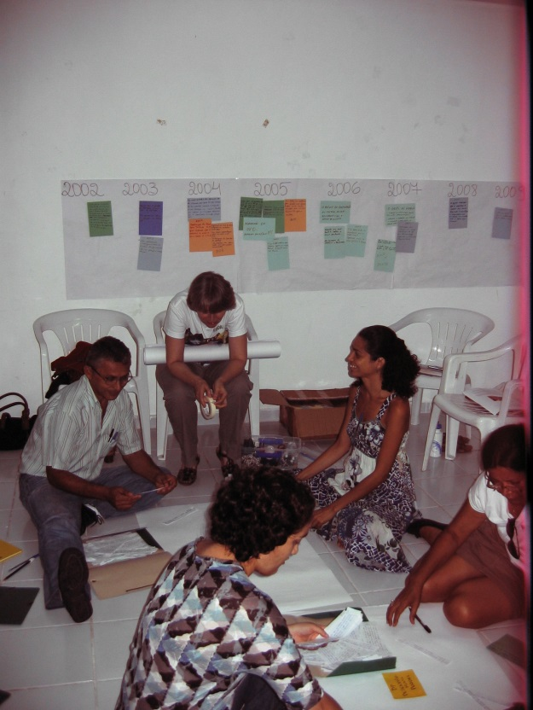

  - Tools

The tools used for collecting data included a combination of quantitative and qualitative tools which allowed us to triangulate the outcomes. The key methodologies included:

Questionnaires: a short questionnaire was designed with closed-ended questions in relation to the main areas of the study. All participants (ex-participants of CPD and young people who didn’t take part in their activities) responded this questionnaire. It was designed to allow a triangulation between the areas of the study, including in relation to gender (e.g. level of schooling vs employment opportunities; level of schooling vs gender). The questionnaire also served as a support in order to draw out issues with the respondents, given that the team that collected the data were trained and oriented to include, wherever possible, spontaneous questions (within the main areas of the study) in order to broaden the volume of data gathered. This strategy of ‘questionnaire and interview’ increased the quantity and quality of information gathered for documenting by the team.

Focus groups (FG): used ‘timelines’ and ‘diagrams of influence’, as well as open questions, to understand the most significant changes in the lives of former participants of CPD. Two FGs were carried out, both focusing on the four key areas of the study and the biggest influences related to these changes, regardless of the source of influence.

Stories of change: through the focus groups and interviews the team identified individuals to tell their ‘stories of change’. These people were invited to describe their stories, which were collected through personal interviews. These testimonies were fundamental to show their personal journeys, their transformation and/or empowerment, as well as the level to which they attributed the changes in their lives to their participation in CPD.

Semi-structured interviews were used with key external actors (priests, pastors, community leaders) in order to give an overview of change in the wider community in the last decade, especially those areas directly related to the study, and the perception of this group about the integration and role of Casa Pequeno Davi and the outcomes that can be attributed to them.

Direct observation: additional qualitative information was collated and used when triangulating data. This was done through transect walks through the community, observing the environment and available services, the situation of children, youth and their families; going into their homes to carry out the interviews the team could see their social, cultural and economic conditions; attitudes and body language of participants of focus groups – including the way people acted within the group (e.g. the silences, respect for other people speaking); posture of respondents when replying to the questionnaire and their openness to answer questions.

Research from secondary sources: documentation from government bodies, census information and CPD reports. This data helped to validate the results and draw conclusions from this study.

  - Analysis of data
The research methodology of this study focused on participatory, qualitative data collection. In order to systematize and group data gathered through a number of different methodologies and with a number of different stakeholders, a coding system was defined to facilitate the process of collecting and analysing data at different stages.
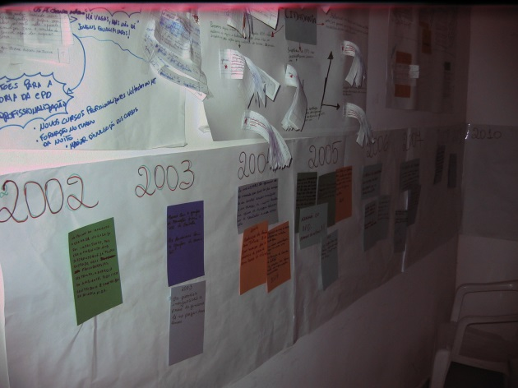
Codes for data analysis
- Personal development (PD)
- Employment (EM)
- Culture of peace (CP)
- Education (E)
- Violence (V)
- Citizenship (C)
- Gender (G)

The key points of each interview, focus group, story of change and of the interactions and interviews, together with the application of the questionnaires, were recorded in notebooks, with their correspondent codes. In the particular case of focus groups, one person facilitated whilst, due to the large amount of verbal information, two enumerators recorded and coded what was said.

Analysis was carried out on the qualitative data through the coded categories. This allowed us to identify: a) in which areas there were more answers and deliberations; b) which were the most prevalent reflections in each category; c) the coincidence or divergence of young people’s views with key actors views or secondary data; d) the internal and external coherence of the discourse; and e) an overall vision of their opinions in relation to CPD and to other influences in their lives.

As well as the qualitative analysis - which involved triangulating the feedback received from a wide range of internal and external sources with observations gathered by the study team and the experience of CPD staff - quantitative analysis was added based on qualitative data prevalence tables and quantitative data obtained from the questionnaires with ex-participants and non-participants. Quotations and case studies were added to illustrate the main outcomes and impacts discovered.

To ensure as broad a learning experience as possible and local partner ownership of the methodology used, this analysis was participatory from beginning to end, from design, to collection and analysis of data, to the finished report. This approach was evaluated by all involved as extremely valuable, even considering the greater time it took to complete.

This next section details the results of this study after analysis of the information gathered. It focuses on the four areas of research: a) Personal development; b) Education; c) Employment; and d) Culture of peace.

- Presentation of the resulting outcomes
  - Personal development

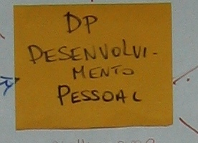
Living in a community that is socially vulnerable, with deficient infrastructure, basic services that are of substandard quality (health, sanitation, and education amongst others), absence of leisure areas, precarious housing, poor food security and nutrition, few opportunities for vocational education and employment is a struggle and all these factors have a significant effect on its inhabitants contributing to low self-esteem. For CPD and Concern Universal, helping to improve self-esteem and confidence is one of the essential objectives that contributes to the personal, educational, professional, social and citizenship development of the participants.

According to statements of the ex-participants, their involvement in CPD helped them to feel capable, strengthened their self-esteem and confidence, helped them to have more control over their lives and to positively affirm their ethnic, cultural and social identities.

“When I arrived at CPD, I didn’t think I was anyone; I now see that I am someone”
(Man FG)

“CPD was a determining factor in improving my self-esteem”
(Woman FG)
69% of those interviewed declared that their self-esteem improved as a result of their participation in CPD, 89% said that they are more confident and 88% that they have more control over their lives.

From the perspective of contributing to personal development, the participants of the focus groups agreed that the formative aspect of the activities offered by CPD was essential in the construction of other skills and future perspectives.

“What you learn at CPD, you don’t learn anywhere else”
(Man FG)

“I feel different because I took part in CPD’s activities and had other opportunities”
(Man FG)

In the focus groups with ex-participants, 54% said that taking part in CPD opened doors and created opportunities – not offered anywhere else – that helped in their personal development and increased their self-esteem, mainly due to the diverse activities and the quality of support offered by the CPD.

“I took part in a recording of a DVD in the percussion workshop”
(Woman FG)

“I took part in a music festival at SESC and we even won a prize at the festival”
(Man FG)

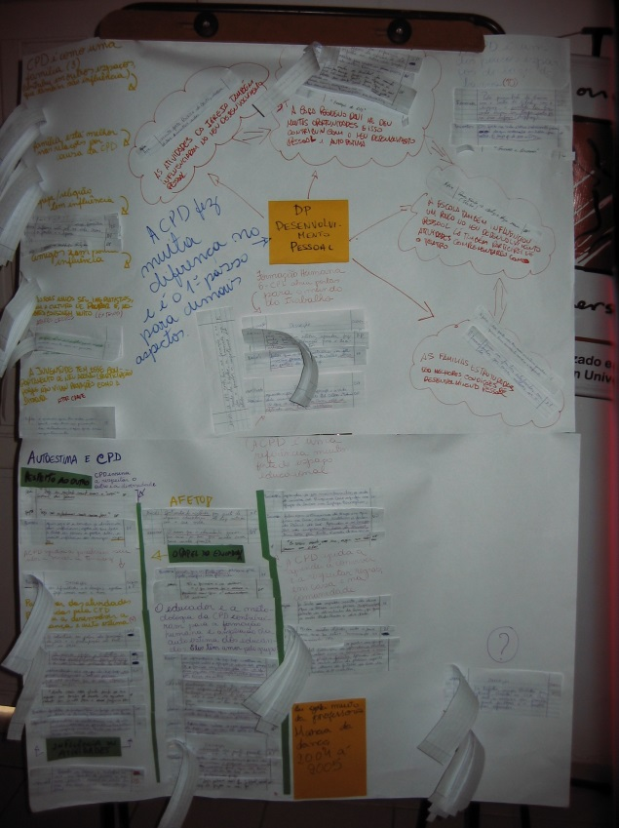
“I travelled to [the town of] Guarabira with a group from the art workshop where we put on an exhibition of the work we had done. I felt very proud to be part of the group”
(Man FG)

“I really liked to play football. I played various games for the CPD team which were played in other neighbourhoods. I won my first medal playing for CPD.”
(Woman FG)

Another factor pointed out by 91% of the ex-participants is that, because of the absence of or inadequate recreation areas in their schools and communities, CPD provides one of the only few spaces for leisure and sports activities in Roger that is free to enter. This is illustrated by the following reflections:

“CPD was my leisure.”
(Man FG)

“In other districts it is difficult to find an organisation like this one, with a range of activity options. I would say that the greatest gift to Roger is Casa Pequeno Davi. It is difficult to find an organsation as accomplished as this.”
(Fernanda Benvenutty* - Key Community Leader)
*Inhabitant of Roger Community; National Health Councillor, local leader, LGBT activist, founder of a local culture association which brings together more than 300 community members (Samba School ‘Império de Samba’)

The majority of the focus group participants pointed out that the personal development workshops that they participated in at CPD were a determining factor in their lives and that, today, they still remember what they learnt. Many recognised that these activities were the most important that they participated in as they brought the most benefits to their lives, principally regarding changing their behaviour in relation to discipline and respect for differences.

“The personal development formation at CPD changed my attitudes. It was really worth it to have taken part in those meetings.”
(Man FG)

“I became a more responsible person because of CPD.”
(Man FG)

“Today I have much more respect for the sexual orientation of others.”
(Woman FG)

The key community actors that were interviewed also confirmed that through its activities CPD taught participants to respect each other, and to live in harmony with diversity. They agreed that most young people just do not have access to the help and guidance offered by CPD in their own homes. According to them CPD has contributed much to the personal development of the young people participating in the activities because, amongst other reasons, it has given them support, information, training and something to do in an area where there are few opportunities, distancing them from getting into fights or getting involved with drugs.

“Children who take part in the CPD activities, or who have taken part in the past, are different; they respect others and have a different way of behaving.”
(Fr. Julio Mason – Key Community Figure*)
*Catholic Priest, Canadian, responsible for the Santa Terezinha Parish in the Roger District during the research period.

“CPD has contributed a lot to the formation [building awareness; understanding; parenting skills] of many parents who participated in activities.”
(Fernanda Benvenutty - Key Community Leader)

In the focus groups 54% of the participants pointed out that the educators had a key role in increasing self-esteem and confidence. The majority of those interviewed said that they felt that the educators really looked after, listened to, and understood their needs. They said that the educators had their best interests at heart.

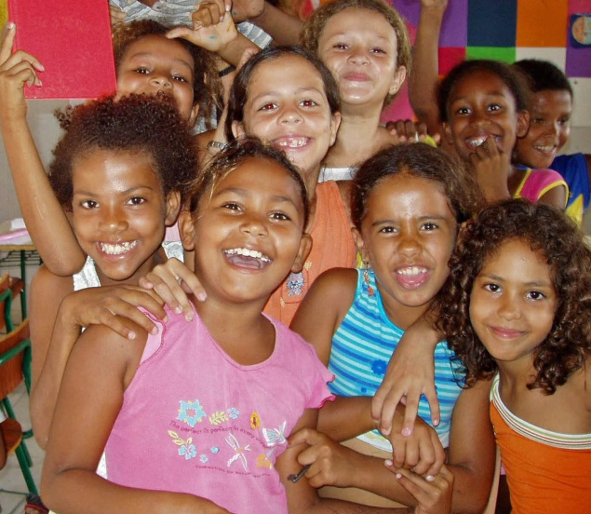
“I really liked the educators a lot. One trip that we did to a beach really had an impact on my life, because I realised that every hour was an hour to teach and learn, even at the beach. It was on that day that I understood why it is important to take care of rubbish [dispose of correctly/recycle], and this is something I still do today.”
(Man FG)

“My teacher [CPD educator] made a real impression on me and encouraged me to finish my studies. I still remember his words today.”
(Woman FG)

“As well as choosing carefully who comes to work at the institution, the ongoing training of the educators has always been a priority and forms one of the main methodological strategies of Casa Pequeno Davi. In this way the educators are qualified to work with the target population of the institution. It was very good to know that this strategy has borne fruit in the lives of the ex-participants, and this encourages us to continue investing in this process. Another factor which has contributed to a more vigilant position on the part of professionals who work in the organisation was the construction, with the help of Concern Universal, of a Child and Adolescent Protection Policy which establishes a set of best practices in our work with children; what cannot be done, and the sanctions for those who break the rules. This document also helps in the recruitment process, reducing the risk of employing people who could turn out to be a danger to those who participate in the institution’s activities.”

Claudia Maria Costa de Lima – General Coordinator of Casa Pequeno Davi

Analysis of the feedback received through this impact analysis showed that: a) the positive affirmation of the young people’s identities; b) their access to a universe of opportunities in CPD; c) their participation in formative processes; and d) the engagement with and understanding of the young people by the educators, were fundamental elements which contributed to their personal development, increased self-esteem and confidence and which constituted a springboard for other areas in their lives.

The efforts undertaken by CPD to promote personal development were evaluated as having a relevant and positive influence for the participating groups, and that as well as recognising its importance, showed the knock on effect in areas such as improved interpersonal relationships and future opportunities – that many were encouraged or inspired to stay in school, and gained the confidence to pursue and achieve educational and professional qualifications, which eventually led to them gaining employment or a way of earning a decent living away from the world of criminal activity and violence.

  - EDUCATION
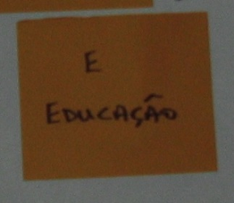
Achieving personal development is a factor that contributes to children and young people, especially those in situation of social vulnerability, having the personal tools and motivation to advance in their educational development. Historically, many children from the areas where CPD undertakes its activities have their schooling interrupted or put back by the numerous social challenges that they face, including hunger, child labour and various forms of violence. This leads to a distortion of normal school progressions from one year to the next, a lack of success in school and truancy. These negative effects were, and still are, a focus of the efforts of CPD which works to help children overcome these situations, so increasing opportunities for a better future.

Educational activities in CPD, which are both integrated* and contextualised and implemented through a variety of ‘educational-play’/pedagogical, artistic, cultural, sporting, vocational and citizenship training activities, are, therefore, carried out alongside social work. The CPD social workers gather information on the social, economic and cultural reality of each participant and their personal, family and community relationships in order to reduce infringements on their rights and protect them from violence, both of which are factors which directly interfere with educational progress and success.

*Integral education is that which promotes the holistic development of the person in all their aspects, bio-psychological and spiritual. It is a sort of education which overcomes that which is merely cognitive, touching on subjectivity, emotion, desires, and sociability, amongst others.

CPD supports young people to improve formal education through:
a) promotion of school attendance; b) support for educational success and development; c) improving parenting skills, especially in relation to their involvement in and accompaniment of their child’s formal education; d) monitoring of the educational progress of the participants; e) ongoing staff training; and f) articulation and training of members of the local social support network for the protection and promotion of the rights of children. Members include other civil society organisations and local public schools.*
*This network, coordinated by Casa Pequeno Davi, discusses and promotes actions to improve child rights in the neighbourhood, especially educational rights.

One of the criteria for children and young people to participate in CPD’s activities is that they are going to school. For some ex-participants this was considered to be a crucial factor in their staying on longer at school, for others it helped them to return to school and for the majority it helped them to progress further in their education. Various participants of the focus groups asserted that CPD helped them to believe in education and understand its importance for a better future. They recognised that the support received in relation to education was of great value, both in relation to support with their homework - taking into consideration that many of their parents or other family members responsible for the children cannot read and write or don’t have time to help - as well as for the opportunity of experiencing integral education as promoted by CPD.

“The studies help to become someone in life.”
(Man FG)

“I learned that studying makes all the difference.”
(Man FG)

“My mother didn’t have time to help me with my school homework; going to Casa Pequeno Davi really helped me.”
(Woman FG)

“The ludo (CPD educational-play activities for children) helped me to become a responsible person [ ... ] as my mother worked all day.”
(Woman FG)

“The strong point was the education that I received at Casa Pequeno Davi.”
(Woman FG)

Another factor that was emphasised by the group that was interviewed was that the methodology used by CPD, based on popular education, contributed to their schooling because it guaranteed their participation in the learning process, a characteristic which according to the group made a difference in the lives of those who took part. It was pointed out that this approach was different from the one used in state schools.

“The themes that were worked on in Casa Pequeno Davi, were always presented within a participatory methodology, different from school.”
(Woman FG)

“Some of the themes tackled by Casa Pequeno Davi were ones that we also worked on at school but in a different way. At CPD I had the opportunity to speak and to clarify doubts, whereas in school I was not able to [...]”
(Woman FG)

At the same time participants of the focus groups recognised that there had been an improvement in the teaching at the schools in the district. These schools have received more investments in the last few years from the federal, state, and municipal governments and had also improved through their participation in the local network previously mentioned.

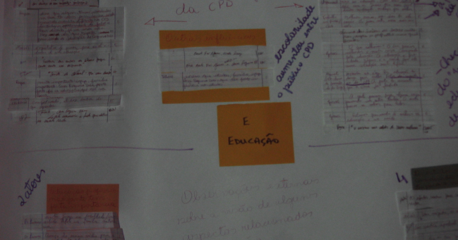
“The teaching in the local schools improved.”
(Woman FG)

“The teaching in the local schools improved. Now the teachers are more qualified.”
(Woman PG)

“The work of the Casa Pequeno Davi is very important in education.”
(Manoel Jacinto Dantas - Key Community Figure*)
*Long-term community resident, father of ex-pupils from CPD and current president of the Roger District Resident’s Association

One important element in the analysis of the education of the ex-participants is its relationship with Child Labour, because of its harmful impact on a child’s educational progress. Children who work exhibit physical tiredness, skip school and have difficulty in concentrating, all of which contribute to high rates of children abandoning school either temporarily or permanently. According to statistics from CPD for the period, we can see that there was a substantial reduction in the levels of involvement in child labour in the participants of the organisation. This was as a result of a number of local actions to address this challenge on the part of CPD, with the help of Concern Universal, and the consolidation of the cash transfer programmes in Brazil during this period.
Figure 1. Source: Casa Pequeno Davi

It is interesting when we look at the statistics in relation to the gender of the participants, we can see clearly that the women ex-participants achieved a higher level of education than the men.

Ex-participants
Women | Men
52% of women completed secondary education | 30% of men completed secondary education
85% of women completed primary education | 64% of men completed primary education

In total, 67% of the ex-participants consulted confirmed that education is one of the areas that CPD helped them the most. The study showed that 26% of the ex-participants (18% men / 8% women), most of whom spent less than 2 years at CPD, did not manage to complete primary education. When compared with non-participants, this number rises to 33%. These figures indicate that the social vulnerability of this group, together with high levels of distortion of the normal school progressions from one year to the next, children dropping-out of school* and a history of poor quality education in the public schools, lead to a high percentage of people in the area not completing primary education during the period analysed. However it is clear that those who had the support of CPD had better opportunities to improve their educational prospects, as 74% of the participants finished primary education, with 44% completing secondary or technical levels, against only 17% of non-participants. Considering that the children who pass through CPD are generally amongst the most socially vulnerable in the area, these numbers are even more impressive.

*(At 24.3% Brazil has the third highest rate of school abandonment in the 100 countries with the highest Level of Human Development UNDP (United Nations Development Programme 2012)

To sum up, the analysis shows that the context in which CPD operates remains complex, with limited possibilities for educational development for the children from the area. This reinforces CPD’s understanding of the importance and the need to continue prioritising education as a key objective in their work, as well as, in accordance with its mission, continuing to influence public policy to improve the quality of formal education.

Case study: Zoreliane Duarte

Zoreliane Duarte, 20 years old. Took part in the Visual Arts and Personal Development workshops, and was an adolescent leader. Today she studies Social Services at the Federal University of Paraiba and passed in 4th place the first time she took the University entrance exam.

Casa Pequeno Davi helped by encouraging me to continue studying and also gave me the incentive to want something better for my community and society. It also taught me about human rights, to see that we all have rights and that we should try to act and help others. And also that we should be in solidarity with one another.
In the workshops we’re valued; we’re taught techniques that we can always use, even in the professional part of our lives.
The educators were great, they talked to you, they wanted to know about you, about where you wanted to go; they always encouraged us to do our best, and wanted the best for our lives and for society in general.
In relation to my family, they always participated in the events and encouraged me to continue at Casa Pequeno Davi; they came and talked to those responsible [at CPD]. They were always there. I was inspired to choose the Social Services course because of the professionals at CPD. “I remembered that the social worker helped me in my life, as well as other professionals [at CPD], and I really identified with them.”

Education for Citizenship

[...] To educate is an act of formation of the conscience – with knowledge, with values, with capacity to understand. In this sense, the educational process is bigger than that which is called formal education that is given in the sphere of school buildings. To educate is to take on board the understanding of the world and of oneself and the inter-relationship between the two [...] (Sader, 2007, p.80)

With the belief that socially vulnerable children have an active role to play in the transformation of their own realities (individual, familial and / or community), CPD has a historic commitment to give them information on their rights, as well as their responsibilities, preparing them for the exercise of citizenship. The figures obtained in this analysis show that 93% of ex-participants learnt that they have rights and 87% affirmed that this knowledge helped them at ‘certain moments’ of their lives. The figure below presents the areas considered to be the ones that were most influenced by the knowledge gained at CPD.

Figure 2. Source: Casa Pequeno Davi

This evaluation by the ex-participants was reinforced by key local actors that were consulted, persons of important reference and community leaders where CPD works, who also highlighted that the activities carried out contributed to the children understanding that they have rights, becoming ‘citizens’ in the broad sense, and that they stand out from other children around them.

“The formal school doesn’t, but should be a place for training, not just in educational subjects, but for citizenship, like at CPD.”
(Fernanda Benvenutty – Key Community Leader)

“It isn’t a slogan; education for citizenship takes place every day [at CPD]. When someone stands out at church, in the pastoral meetings, when I go to find out about them, I find that they have already been through Casa Pequeno Davi at some point.”
(Fr. Júlio Mason – Key Community Figure)

Throughout the years, CPD has promoted the collective exercise of citizenship, with various successful cases, one of which was an advocacy initiative by a group of children with the help of their educator. This group undertook an analysis of the open drains in the community, starting with the street where CPD is situated, and organised a meeting with the then Secretary for Public Transparency in order to lobby for better services for their community from the Municipal government.

From these group initiatives both individual and collective results have been achieved, for example the storm drains described above were cleaned as a result of the actions of the children, and new leadership emerged for the communities and for the ‘Child and Adolescent civil society Movement’, in João Pessoa.

Life Story of Lindinalva Oliveira

Lindinalva Oliveira 19, is a 3rd Year, Secondary Education Student. She works as a popular educator of theatre and dance in the More Education Programme at a school in Bayeux and carries out consultancy work in the area of infant/juvenile protagonism* at REMAR (Municipal Network for the Rights of Children).
*A proponent for or leader/advocate of a social or political cause, e.g. child rights.

Casa Pequeno Davi was important for my development because today I am working. In the area in which I work it helped me a lot! It was through Casa Pequeno Davi that I found my enthusiasm for it [being a protagonist] and today I work with youth protagonists at REMAR. The certificate I got for the information technology course at CPD was important; it really helped with my curriculum. This, as well as the vocational training, helped me in my development as a human being. CPD was a part of my life for a long time – 4 years – and really helped me in my development as a person. Everyone from the psychologist, the social worker, the educators, always helped me.

“As a child I had no choice but to work. I even took part in the documentary “At what cost?” made by CPD about child labour. I stopped working to go to CPD. I sold snacks in the local shopping centre “Quatro e Quatrocentos”, and even lost a year of school because of the work. I stopped working when I went to Casa Pequeno Davi.

Casa Pequeno Davi helped my whole family, my mother also took part in the training of the group of ‘family leaders/protagonists’. If my mother understands me today it is thanks to the training that she received at Casa.

What I learned at Casa I passed on to everyone in my house. My mother didn’t really understand what I liked doing, this art thing. She really didn’t understand! She only began to understand when she started to take part in the workshops. Today she understands. Today she has accepted my choice of art, but my mother wanted me to do medicine.

[Lindinalva feels that she is different from other young people of the same age]. I have a lot of political awareness. CPD awoke my political awareness. I am a “non-conformer”, “I learned not to let my rights be violated”.

Casa Pequeno Davi is a really good place, very useful, and it should continue the work that it does. The people that participate there certainly are people who are going to stand out. They are people who can stand out in whatever area they choose.

Although a lot of positive evidence has been collected, one element identified through this impact analysis was that, even with a greater knowledge of rights - which has been used to the benefit of both themselves and their families - and even with their prior participation in ‘collective citizenship’ activities whilst in CPD, few ex-participants are involved with any community group. This limits the amount of knowledge that is being passed on within their communities and the possibility of their active involvement in other group actions for the benefit and well-being of the wider community.

As ‘citizenship’ was not one of the original four areas of investigation, the data gathered was insufficient to draw definitive conclusions as to why participation is low. However, it is clear that any analysis cannot be separated from the context of poverty in which the majority live: most of the participants have to concentrate their energies on trying to make enough for their families to survive, limiting their concern with wider community challenges. Moreover, locally there is no tradition of participation in the decision-making that affects their lives and the formal structures for political participation are, in general, not accessible for this group.

Finally, the majority of the public consulted presented strong evidence that CPD had a great influence in the educational progress of those who participate in its activities, both in relation to formal education and in the construction of citizenship. This learning was evaluated as being really important in the lives of the ex-participants.

EMPLOYMENT
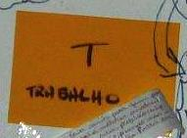
To have a future where it is possible to be a citizen, to have autonomy, removed from the world of violence and from dependence on government welfare, it is necessary to have the means to make a living. For this, it is necessary to be aware of the need and importance of work, as well as to have the necessary skills or qualifications to get a job.

As a response to the widespread context of social vulnerability and the limited opportunities for job training for young people in the locality, since its early years CPD offered activities that build both technical and social skills that facilitate opportunities to enter the job market, become self-employed or, if necessary, to earn a living in the informal sector. These formative processes start with personal and educational development, following up with basic vocational training. They raise an understanding of the world of work and inspire the setting of life goals.

“Many young people managed to get into the job market because of the
job training and support they received from CPD”.
(Pastor Lourenço* – key community figure)
*Baptist Minister, Roger community.

According to those interviewed, CPD is influential in preparing young people from the area for the job market, including being able to directly connect some young people with job opportunities. 63% of ex-participants who are working or have worked agreed that their participation in CPD was key to landing a job.

“CPD opened doors for me”
(Man FG)

“CPD was decisive in my getting a job”
(Man FG)

CPD includes ex-participants as staff members, wherever possible, giving them an opportunity for their first job. Also, via a project 'Saudade' (supported by a group of Dutch individuals), CPD invests in ex-participants with specific training in areas that are of interest to them, to help them get a job or earn a living in the informal sector. This contributes directly to their personal and professional growth, encouraging them to continue onward, continue advancing, within or outside of our organisation.
Dimas Gomes – Administrative Coordinator, CPD

Despite a strong prejudice against those who live in the localities where CPD works, because they are poor areas – and, in the case of Roger neighbourhood, because a prison is located there and the city dump was based there for more than 50 years – this impact analysis confirms that those who participated in the organisation’s activities had better chances to join the formal job market, when compared to those who did not participate. In many cases they also received a higher level of pay.

Ex-participants of CPD | Non-Participants
70% of ex-participants that are working have a formal job  15% work in the informal sector (odd jobs, etc.); 15% are self-employed. | 33% of non-participants have a formal job; 50% work in the informal sector; 17% are self-employed.
33% of ex-participants that are working earn less than a minimum salary; 67% earn at least a minimum salary (£190 per month). | 67% of non-participants that are working earn less than a minimum salary.
38% of ex-participants receive some type of social welfare benefit (ex. via the Federal Government cash transfer programme ‘Bolsa Familia’). | 50% of non-participants are in this category.
Source: Questionnaires – Concern Universal – March 2013

The training opportunities offered, the personal development formation, skills building and/or greater self-esteem were the factors that made the difference in relation to ex-participants joining the job market, or gaining a better paying job.

“My son got a job thanks to the training he received in CPD”
(Juracy Mesquita – Community Leader)

“My participation in the music workshop was what gave me the confidence
to look for and get a job”
(Man – FG)

“CPD is the embodiment of training and formation of youth; the neighbourhood is privileged to have CPD here”.
(Fernanda Benvenutty, Key Community Leader).

Life story of José Rosielmo

José Rosielmo, 22 years old. Participated in IT, silk-screen printing and personal development workshops
[My participation in] Casa Pequeno Davi kept me away from a lot of very bad things. CPD helped me a lot with my life; the personal development and IT workshops were particularly helpful with this. CPD helped me to have a more structured life. Education in itself was everything; Casa Pequeno Davi gave me this.

The worst day of my life was when I turned 18; when I had to leave CPD and make my own way in life. Because I lived in a low-income community, it was inevitable that life offered me many bad things – drugs, trafficking, child labour. But CPD freed me from all that. The thing I suffered with most was when I worked as a child. When CPD rescued me I was working in a quarry, loading rocks onto trucks. I was 14 or 15 years old.

Although there was a time when my parents didn’t want to participate as things were tough [financially], the formation that they received in CPD also helped a lot. At one stage, they didn’t want to let my other brother study [they wanted him to work to help with the family income].

In relation to my professional life, [what I learnt in] CPD helped me to get a job. It was there that I learnt everything about silk-screen printing. It was there that I received encouragement and developed my skills in the area that I work today (silk-screen printing). I left there knowing that I wanted to work with silk-screen printing and ‘final art’ (graphic design).

José Rosielmo is married and works in a printing shop in the city. He helps other youth who, like him, participated in CPD, linking them to available jobs in one of the shops his employer owns. Today he is a reference for other young people from his community. Before getting a job a couple of years ago, he worked part-time teaching silk-screen printing and IT in CPD. He has a brother who was his student and now, as a result of his encouragement, also works with silk-screen printing. Rosielmo thinks that he is a good husband because he went to CPD. “The way I talk to her, the way we agree on things, I owe to Casa Pequeno Davi”.

One aspect clearly evidenced by the impact study was gender inequality in relation to access to the job market (formal or informal sectors). Although female ex-participants had a higher educational level than their male counterparts, as outlined in the section 'Education' above, they have not been able to access work to the same degree and, when they are able to, in general they earn a lower salary.

Ex-participants
Women | Men
38% of the women interviewed are working | 61% of the men interviewed are working
80% of the women that are working earn a minimum salary or less | In comparison, only 43% of the men that are working earn a minimum salary or less with 57% earning more.

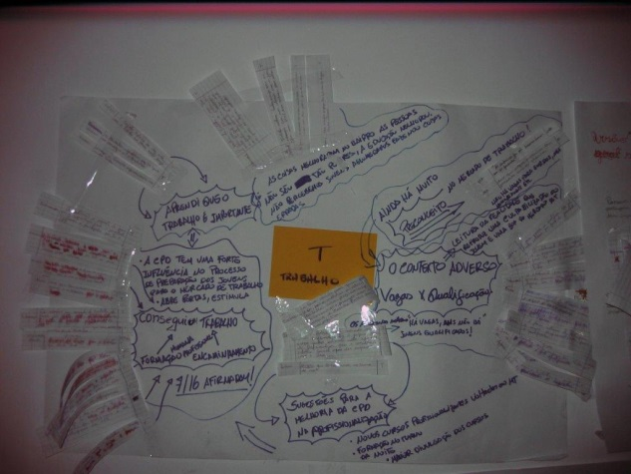
In the focus groups, female ex-participants said that it was very difficult to gain access to a first job; that there is prejudice against young women, pregnant women, obese women, black women and “those that don’t have perfect Portuguese”.

Another factor that reinforces this inequality is the culture of ‘machismo’ that is prevalent in Brazil, and even more so in the Northeast region, and that imposes social norms for men and women. The patriarchal culture that exists creates barriers for women to access the formal job market. Considering that women are expected to look after the house and care for the children, a further barrier to their accessing the job market, or earn a living in the informal sector, is that there are few childcare facilities in the locality. 65% of the women that participated in the study have at least one child. The few government supported crèches that exist, where mothers can leave their children in safety so that they can work, have very few places.

According to the Government City Plan 2013-2016, in João Pessoa only 12.04% of children under the age of three are in day-care. The consequent 87.6% demand for childcare places indicates fragility at a policy level, that is also a reflection of the existing ‘gender segregated culture’.

In 2011 CPD and Concern Universal supported an advocacy initiative for more public day-care places in the Roger neighbourhood. This initiative was carried out by a group of local community leaders using the Concern Universal advocacy methodology, an accredited social technology in Brazil - ’10 Steps to Citizenship’. After eight months of community mobilisation and various meetings with local government representatives, which took place both within the community and in government offices, in 2012 they succeeded in their quest. The original crèche was moved to a larger and better structured public building in the community, increasing the number of places from 60 to 150.

According to the ILO, the level of youth unemployment in Brazil is between 14% and 19% - considered moderate. This impact study shows that the rate of youth unemployment in the locations where CPD works is nearly twice the national average, as 30% of the ex-participants (18% women) and 33% of non-participants (25% women) have never worked. Considering the complex local context and external variables that interfere with access to the job market, this study also shows, as confirmed by the majority of those interviewed, that their participation in CPD activities had in general a positive influence in preparing them for the world of work.

At the same time, the difference between national and local data collected indicates a need for continued actions and the development of new strategies to ensure the right of young people from these areas to a livelihood, with a special focus on the question of women and the job market.

  - CULTURE OF PEACE

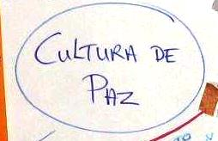
As CPD was receiving repeated reports of violence in the homes of participating children and as various staff educators were also perceiving this fact, from 2002 onward reducing ‘domestic violence’ became a particular focus of the organisation.

Apart from this situation of recurring domestic violence, easy access to drugs (use and trafficking) has been a serious problem for a long time in the areas where CPD works, leading to violence, including homicide. This situation is so prevalent in João Pessoa that, with a continuous stream of children (under 18’s) involved in the city, it is ranked third amongst Brazilian capitals in relation to homicides of children.

For this reason, one focus of this study was to analyse if the actions carried out by CPD from 2002-2012 had a positive impact on the lives of the children that participated – and as a consequence, their families and communities – in relation to them overcoming situations of violence through ‘living a culture of peace’, through the use of dialogue (personal, family and community), apart from a higher resistance to entering a world of drugs and crime.

During the consultations, the key community stakeholders and focus group participants stated that there has been a large youth involvement in excessive consumption of alcohol and other drugs, as well as with drug trafficking, in recent years in the community:

“There is a proliferation of drugs in the neighbourhood”
(Man FG)

“Young people are involved in trafficking drugs in the neighbourhood; but they are also victims of drug use”.
(Woman FG)

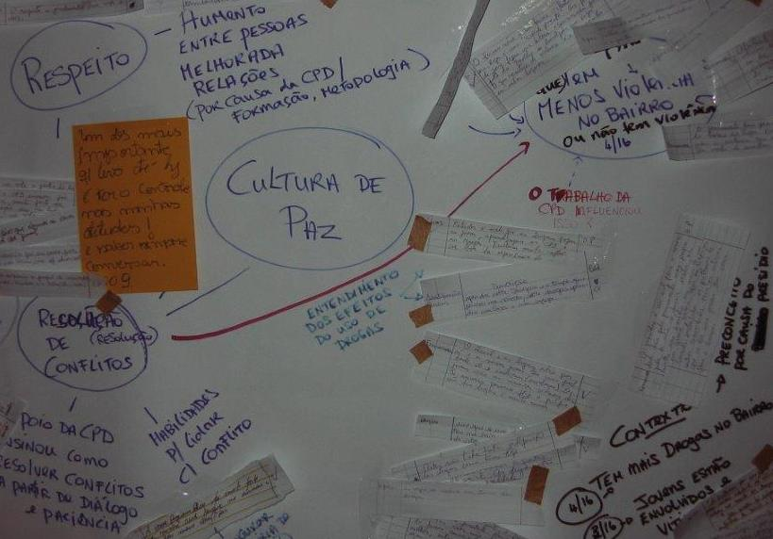
“[..] At times they [youth] meet up around drugs [to take drugs]”
(Fr. Júlio – key community actor)

“[...] young people still get involved with drugs [...]”.
(Pastor Lourenço – key community figure)

“Alcohol and drugs are out there and it’s easy for our young people to get involved [...] Today the proliferation of drugs is much higher”.
(Fernanda Benvenutty, key community leader)

Interestingly, during the interviews, the majority of key community actors did not establish a direct link between drug use and violence; rather their perception is that violence in the neighbourhood of Roger has reduced in recent years, despite the worsening violence in the city and the State.

“People from Roger stay out until late at night sitting and talking in front of their houses; this wouldn’t happen if it was very violent here”
(Pastor Lourenço – key community figure)

“As for violence, it’s not like it was before; nowadays it’s reduced [...]”.
(Juracy Mesquita – community leader, Roger)

“Compared to other neighbourhoods, it is better [...]. It’s not common to hear people complaining of violence.”
(Fr. Júlio – Key Community Figure)

“At the moment, this neighbourhood is not a source of news for the media in relation to violence, as it once was.”
(Fernanda Benvenutty, key community leader)

Considering the above, it would appear that for these community actors their understanding of ‘violence’ is physical violence, and especially lethal violence.

According to the Paraíba State Secretariat for Public Security and Social Defence (SEDS), in João Pessoa there has been a sharp growth in the rate of Intentional Lethal Violent Crimes (CVLI). Intentional homicide and other intentional violent crimes leading to death reached a CVLI rate in 2012/2013 of 66.9 per 100,000 inhabitants, making it the ninth most violent city in the world (for cities with over 300,000 inhabitants) and the 3rd most violent capital city in Brazil.

Contrary to this, SEDS Paraíba data shows that the rate of CVLI in Roger reduced successively for the period 2011 to May 2013, as evidenced by the chart below which includes data from the neighbourhood as well as from the prison located there. This data reinforces the views of the key community actors that were interviewed.

Figure 3. Source: SEDS/PB

At the same time, those ex-participants who had experienced violence at close quarters as a result of the involvement of their relatives or friends with drugs, were of the view that getting involved with drugs, whether use or trafficking, will lead to violence, including lethal violence.

“My brother was buried alive because he got involved with drug trafficking”.
(Woman FG)

From the statements of one of the community actors, we can also identify a viewpoint that drug users are victims of a much broader context of a lack of opportunities and access to basic public services and policies.

“[...] young people are the greatest victims of this perverse universe [...] young people lack opportunities. Our neighbourhood [Roger] does not have what is needed [youth policies and services] to promote the development of young people [...]”
(Fernanda Benvenutty, key community leader)

Considering this local context, for the key community actors interviewed, CPD is one of the key influences in removing many children and young people from harm arising from the consumption and trafficking of drugs.

“As a result of omission on the part of the local authorities, it is CPD that occupies a central place in the community for youth”
(Fernanda Benvenutty, key community leader)

“I understand, because of CPD and the church, the harm that drugs do to youth [...]”
(Man FG)

Reinforcing this, according to information obtained from staff members that work for the organisation, it is not normal for ex-participants and participants of CPD to get involved in drug trafficking and crime. Although there has been no systematic monitoring of young people once they leave the organization, the fact that CPD is based within the Roger community facilitates its contact with a continuous flow of information about everything that happens in the neighbourhood.

Life story of Moisés Nascimento

Moisés Nascimento, 19 years old. Ex-participant and currently Music Teacher / Educator

Casa Pequeno Davi has contributed to my story, especially as when I first went to CPD I was going through a very difficult time in my life. I tried to get into CPD initially when my family was not too poor, but because of this I didn’t meet the criteria, so wasn’t accepted. Then, in that same year, my life started to change. My family went through a lot of difficulties; my father lost his job, got involved with drugs and life became difficult. The following year I was accepted into CPD. My mother died not long afterwards. Our reality totally changed; CPD became a great support for me, helped me greatly.

CPD opened the door for me and gave me my first job. From the beginning CPD prepares you to be a good professional; the training process leads you to this. I want to stay here for as long as I can!

The training process in CPD is continuous and is a contributing factor in my life. What you learn stays with you forever, for your whole life. Also, for me, music has been a major factor in my growth as a citizen, as an educator and professional.

Another way that I was helped was in relation to citizenship. I was on the road to becoming a criminal, a drug trafficker, to getting involved with drugs. The other day the pastor said to me "this boy is a miracle because he could very easily be involved in everything that’s bad, but today he is a music teacher, working at Casa Pequeno Davi." I could so easily have gotten involved [with drugs and crime]; it’s just as well that I managed to say no, but the road to drugs is just out there [very near]. Many others have not been so lucky.

Music has been Moisés’ great inspiration. In 2011 he started giving music classes to children in CPD. CPD welcomed him and inspired him to become an educator and to help other young people.

Respect, tolerance and peaceful conflict resolution:

CPD’s reports over the years show that their greater focus on a formative process with the children’s families in relation to 'how to educate without violence', together with an approach used in all activities to further a 'culture of peace', resulted in better relationships between parents and their children.

During this impact analysis, the ex-participants confirmed that their participation inspired and still inspires them to value respect, tolerance and the peaceful resolution of conflicts. 91% of those consulted via questionnaires stated that, for them, dialogue is the best way to resolve conflict and, of these, 94% attributed this understanding to their participation in CPD.

“CPD taught me to remain calm in order to resolve problems in my relationships” – (FG participant)

“CPD was a strong influence in my life because it taught me how to resolve conflicts” – (FG participant)

The focus group participants expressed how important it was that CPD welcomed and accepted them; this helped them throughout their lives and had an impact on their relationships with their families and within their communities. 97% of all questionnaire respondents rated CPD as ‘very important’ or ‘important’ in changing their lives for the better. Of these 86% said that one thing that changed for the better, as a result of their participation, was that their family relationships became more tranquil.

“Respect is fundamental in a couple’s life”
(Man FG).

“Today I respect my parents because of the education I received at CPD”
(Woman FG)

According to what participants in the study said, the work of CPD had a clear multiplier effect. Although the organisation works primarily with children, Focus Group participants stated that they also perceived changes in their families, due to two main reasons: 1) because parents or guardians (mostly women) regularly participated in formative workshops, where the same topics that were discussed with the children were also discussed with those responsible for them; and 2) because of the influence of the CPD educators, their understanding and the way in which they taught about how to resolve conflicts and improve dialogue, which was transferred by the participants to their families, influencing family life.

“CPD made my family better! There were no conversations or dialogue in my house, but after I started with CPD I began talking to my father more. It was easier with my mother because she also participated in the meetings at CPD.”
(Woman FG)

For many of the interviewees both CPD and their church were the principal positive influences in their lives. Some of the participants said they felt that CPD was 'like a family'.

“Casa Pequeno Davi was one of the strongest influences in my life”
(Woman FG)

To sum up, we cannot confirm that there is less violence in the neighbourhood of Roger because of CPD, but we can conclude that there were positive impacts on the lives of the majority of those who participated in its activities with respect to overcoming situations of violence in the home and resistance to getting involved with drugs and crime. The ex-participants consulted confirmed that their participation in CPD brought about changes in their attitudes with regard to respecting others, greater tolerance and the use of dialogue as an effective way to resolve conflicts; that there is less violence in their families, which led to children being more protected in these home environments. It is likely that, as a result, these families have, as a matter of course, spread this experience, this ‘culture of peace’, contributing to improvements in the community environment and, thus, to reduce violence locally, contrary to recent developments at national, state and municipal levels.

- Conclusions and recommendations
This analysis was carried out to assess whether the participation of children and young people in CPD activities contributed to improving their lives as adults and, in doing so, highlighting the most successful strategies, eventual limitations and prevailing challenges. The findings will feed in to the planning of strategies and methodologies to be used in the coming years.

Our findings from the triangulation and comparison of the data, information, statements and stories received in relation to the four chosen areas of enquiry, indicate that participation in the activities did indeed make a positive difference to the lives of the majority of participants. From what the ex-participants said we can also confirm that the support that they received when children also extended as benefits to their families and, to some degree, to the communities where they live.

According to the ex-participants:
- 89% of them are more confident and 88% have more control over their lives;
- 74% finished primary school; 44% completed secondary or technical college;
- 63% confirmed that their participation in CPD was fundamental to them getting a job;
- 93% learnt that they have rights; 87% assured that this learning contributed at some point to their lives;
- 91% said that, for them, conversation or dialogue is the best way to resolve conflict; of these, 94% attributed this understanding to their participation in CPD.

CPD are very pleased with the very positive results of this analysis. At the same time this valuable analytical exercise has raised a number of learning points that will make CPD’s actions and strategies more effective and ever more relevant to the real, diverse and changing needs of children from the target areas.

- Personal Development:

The investment in personal development was one of the clearest benefits for young people. They recognised that greater self-esteem and confidence was the cornerstone that enabled them to have more control over their lives and, consequently, better chances of progress, both personally and professionally. Because of this, CPD believes that activities and methodologies that promote the personal development of children should remain a focus of actions carried out by the organisation and that methodologies used should be consistently reviewed and renewed to ensure that they remain effective and relevant to the changing local context.

- Education:

Formal Education: the analysis showed that the majority of ex-participants progressed in relation to their formal education, many attributing this to the support received, showing that the focus on education as a central strategy was correct.

However, the analysis also showed that 26% of those that participated during the period 2002-2012 did not complete primary school. We were able to ascertain that the majority of these (65%) participated in CPD for no more than two years. However, there wasn’t scope within this study to draw further conclusions, as additional detailed information, necessary to an analysis, were not collected. This information would include, for example, the progress of each participant within the primary school system, the specific context of each and of the school that each attended.

Overall, considering the good results to date, and given the local context and the importance of a formal education for future opportunities, this will remain a priority focus for CPD in coming years. The findings also indicate that CPD should pay greater attention to the monitoring of the educational progress of each participant, where possible cross-referencing this with each child’s particular context. Considering that this task is the responsibility of local schools confirms the necessity for CPDs continued interaction with these important actors. Taking into account that the obligation to provide a good level of educational services is the responsibility of government, at municipal, state and federal levels, CPD believes that any direct action with children on the ground must continue to be complemented by proactive participation at a policy making and discussion level to influence for an improvement in the quality of formal education locally and CPD will continue to do this.

Education for Citizenship: It became clear during the analysis that the educational process used built knowledge that goes beyond formal and cognitive development. It touched on subjectivity, emotion, desires, sociability, and especially the sense of citizenship, of empowerment, providing a stimulus to transform individual realities through the quest for the realisation of their rights.

The process of ‘education for citizenship’ has been highly relevant to the ex-participants, with individual changes to attitudes and lives reported as a result of the assimilation of information about rights. However, considering that few participate in any type of community group – a fact that limits their potential to use their knowledge to actively contribute to processes for improvements in the areas where they live – CPD believes that encouraging the greater involvement of actual and future participants could well bring benefits to the communities and, consequently, to themselves and their families.

- Employment:

The majority of ex-participants and community actors consulted recognised that participation in CPD activities increased possibilities to access the job market or earn a living in the informal sector. The personal development formation was seen as important to build self-esteem, confidence and citizenship, and this, together with skills training, made all the difference to improving the chances of ex-participants getting a job.

Notwithstanding the good results to date, the study also shows that 30% of the ex-participants have never worked and that, despite having a higher educational level than their male counterparts, the female ex-participants have not been able to access work opportunities to the same degree. Furthermore, when they are able to, in general they earn a lower salary, indicating little change in the historic context of economic and social inequality of women in relation to men.

Therefore, apart from maintaining Education and Personal Development as priority foci because of their importance in preparing young people for a future working life, CPD is planning to revise, and periodically review, strategies in relation to ‘work’ to ensure that vocational training activities reconcile the community job profile to an ever more demanding job market. At the same time, it will build the skills and abilities necessary to improve the chances of young people to make a living, when necessary, via alternative strategies to the formal market (ex. creative or solidarity economy).

Furthermore, considering the difficulties that female ex-participants reported having in getting a first job, CPD will consider it especially important to ensure that this is taken into account when developing these strategies. CPD will continue to strengthen links with local companies, which could help to facilitate employment opportunities for first-time applicants. Apart from this, considering that job creation is a responsibility of government at all three levels, new strategies could include, for example, advocacy initiatives to influence for a municipal policy for the productive inclusion of young women.

- Culture of Peace:

As confirmed by the interviewees, participation in the activities made ​​a difference in changing the attitudes of ex-participants with regard to respect for others, greater tolerance in their interpersonal relationships, the use of dialogue as an effective means to resolve conflicts, and also in their homes, making them more protective environments.

Given the growing abusive use of alcohol and other drugs throughout the city, as well as a more evident involvement of children and youth in trafficking, CPD considers it imperative to continue activities that promote a 'culture of peace' and encourage resistance to entering the world of drugs and crime.

Furthermore, considering that in João Pessoa most violence against children happens within their own homes, CPD believes that it is of the utmost importance to continue carrying out workshops with the participants’ families, encouraging them to 'educate without violence' and so that they understand and carry out their responsibilities towards their children to ensure that they are fully protected in their homes and communities.

Other learnings from the development, implementation and systematization of this Impact Analysis

This collective analytical process of the history of the work of CPD and CU in Brazil, which could not have been carried out without the involvement of staff and volunteers, was a great learning opportunity for all involved. The combined set of methodological tools used contributed decisively to identifying the impact of both organisations’ work, and the learning gained on these methodologies will facilitate the possibility of similar studies to be carried out by CPD and Concern Universal, as well as for other partner organizations.

Another lesson learnt from this study was that in order to facilitate the systematic measurement of impact of our initiatives, better organisation and quality of data on children and youth who participate in activities is needed. Even though CPD does have a database of participants they were not able to extract the information quickly or easily given typing errors such as duplication of names. This challenge will be addressed during 2014, with the expectation that future data will be correctly and accurately inputted to facilitate the day to day working of CPD as well as future studies that may be carried out.

It became evident during the preparatory phase of this analysis that, even though the project buildings are located within Roger community and some employees live in the neighbourhoods where CPD works, there is a need for systematic communication with the ex-participants, as this could provide important information on a regular basis that can feed into our understanding of the impact of the work and, consequently, to the revision of strategies to ensure their ongoing relevance, efficiency and effectiveness. Some strategies that could be used to facilitate this communication include the development of groups using social networks; or the setting up of an online database via the CPD site to link ex-participants with possible job opportunities.

Finally, as much as Brazil portrays itself as a country on the way to reaching developed status, and certainly there have been advances in recent years, the reality in the communities where this study took place proves there is still a long way to go to reduce poverty and vulnerability. The prevalent social and economic difficulties that exist continue to be barriers to the development of skills and citizenship in these localities. This context indicates the need for continuity and strengthening of CPD’s and Concern Universal’s work locally as well as the ongoing revision of strategies to resolve the challenges that socially vulnerable children, young people and their families in Paraíba continue to face.

Participatory approaches permit the active and effective involvement of participants in the educational process without considering them mere receptors where knowledge and information are deposited. The participatory approach values the knowledge and experiences of participants, involving them in discussions where there is identification of and a search for solutions to the problems they have to deal with.
E.g. the consolidation of the cash transfer programme for families living in extreme poverty.
Training offered in the locality, by government bodies, in general does not take into account the characteristics of young people from the area with prerequisites (such as schooling level) that exclude the majority from participating.
CPD has developed partnerships with a number of businesses in the city. From time to time, as a result of these partnerships, young people who participated in CPD’s activities gained their first job.
International Labour Organisation - 2012
Brazilian Map of Violence 2012 (http://www.mapadaviolencia.org.br/).
Roger was chosen to carry out the analysis of this part of the study as it is where the work was mainly carried out and as reliable secondary information was available for the area.
Mexican NGO “ Citizen Council for Public Safety and Criminal Justice” – 2013
CPD staff members were one of the target groups heard in this study in order to collect secondary information, of which ~15% live in Roger.
Disk Human Rights 2014 (BR) report, Disk 100.

